**Software Testing Assignment**

**Q 1) Check whether the considered module is structured or unstructured.**

**Solution-)** The Considered Module is Unstructured.

**Q 2) Measure the Cyclomatic Complexity.**

**Solution-)** The Cyclomatic Complexity is measured by following methods:

a) V(G) = E – N + 2 = 19-14+2=7

where E = No. of Edges

N = No. of Nodes

b) Number of Closed regions = 7

c) Number of Predicate Nodes + 1 = 6+1 = 7

**Q 3) Locate and Document the need of enchancement in Program to make it structured one.**

**Solution-)** To transform it into a structured program. We will change the structure of While loop and integrate all the If-Elif statements into a function.

**Q 4) Design and Document test case to validate test path using control flow testing approach.**

**Solution -)** Test Paths and Control flow of Calculator Program:-

There are 7 Independent Test paths of the control flow graph:

1) 1-2-3-4-6-8-10-12-14

2) 1-2-14

3) 1-2-3-4-7-14

4) 1-2-3-4-6-9-14

5) 1-2-3-4-6-8-11-14

6) 1-2-3-4-6-8-10-13-14

7) 1-2-3-5-2-14

**Control Flow:-**

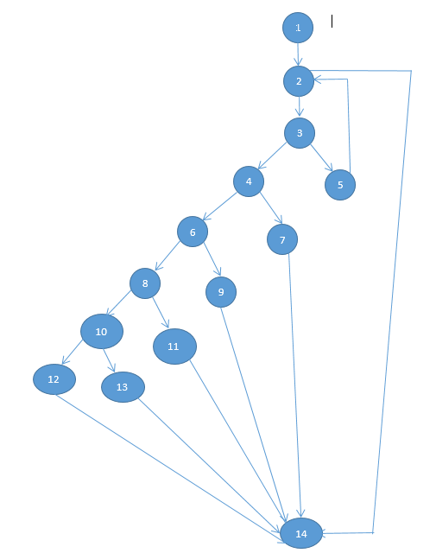

Programiz

Search Programiz

Python Program to Make a Simple Calculator

In this example you will learn to create a simple calculator that can add, subtract, multiply or divide depending upon the input from the user.

Python Functions

Python Function Arguments

Python User-defined Functions

Example: Simple Calculator by Using Functions

# Program make a simple calculator

# This function adds two numbers

def add(x, y):

return x + y

# This function subtracts two numbers

def subtract(x, y):

return x - y

# This function multiplies two numbers

def multiply(x, y):

return x * y

# This function divides two numbers

def divide(x, y):

return x / y

print("Select operation.")

print("1.Add")

print("2.Subtract") 1

print("3.Multiply")

print("4.Divide")

while True: 2

# Take input from the user

choice = input("Enter choice(1/2/3/4): ")

# Check if choice is one of the four options

if choice in ('1', '2', '3', '4'): 3

num1 = float(input("Enter first number: "))

num2 = float(input("Enter second number: "))

if choice == '1': 4

print(num1, "+", num2, "=", add(num1, num2)) 7

elif choice == '2': 6

print(num1, "-", num2, "=", subtract(num1, num2)) 9

elif choice == '3': 8

print(num1, "*", num2, "=", multiply(num1, num2)) 11

elif choice == '4': 10

print(num1, "/", num2, "=", divide(num1, num2)) 12

break 13

else: 5

print("Invalid Input")

**Node Number 14 is end node**